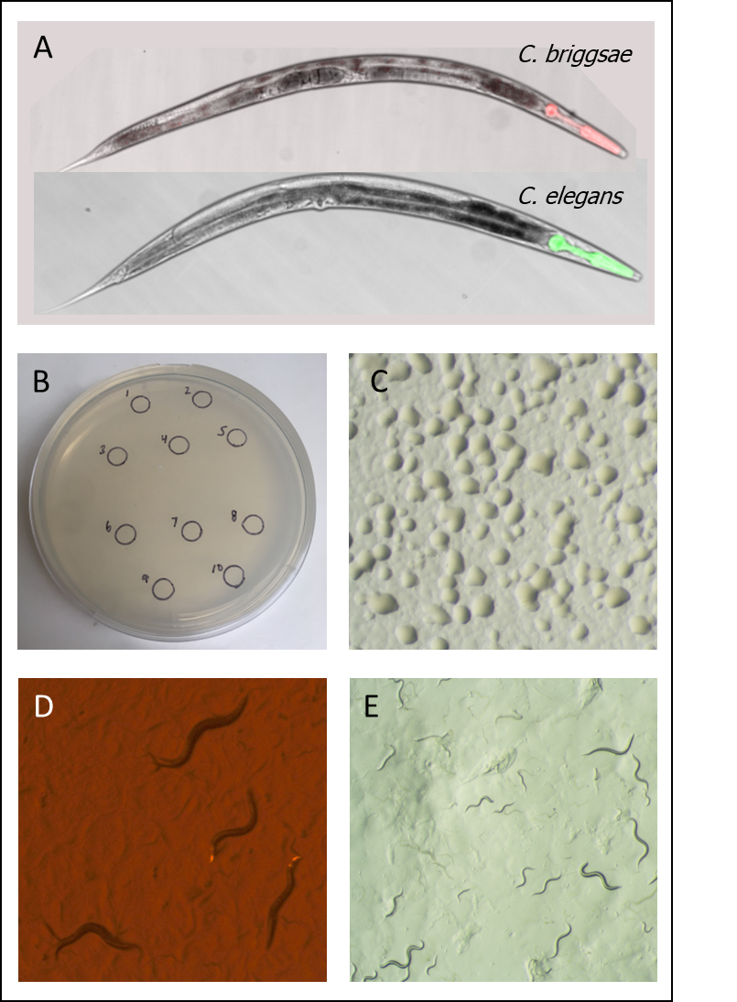**Supplementary Material**

**Dormancy promotes coexistence in fluctuating environments.**

**Fig. S1.** A) Example strains used: *C. briggsae* strain JU1018 and *C. elegans* strain CGC59. B) 9cm NGM-lite plates seeded with OP50 *E. coli* used in experiments C) Close up of *E.coli* lawn. D) Early in the experiment, worm density is low and food density is high. E) After resources are depleted only worms that have entered dauer survive the subsequent SDS treatment.

**Fig. S2.** Experimental protocol for the monoculture experiment to determine the model parameters. Each strain was grown by (1) haphazardly picking two individuals at the L4 stage, before eggs had developed, onto 9cm NGM-lite plates with a 500 µl lawn of OP50 *E. coli.* We measured the maximum growth rate (2) and after the populations crashed (3), we washed (4) and replated the dauer worms to calculate the investment in dauer (5).

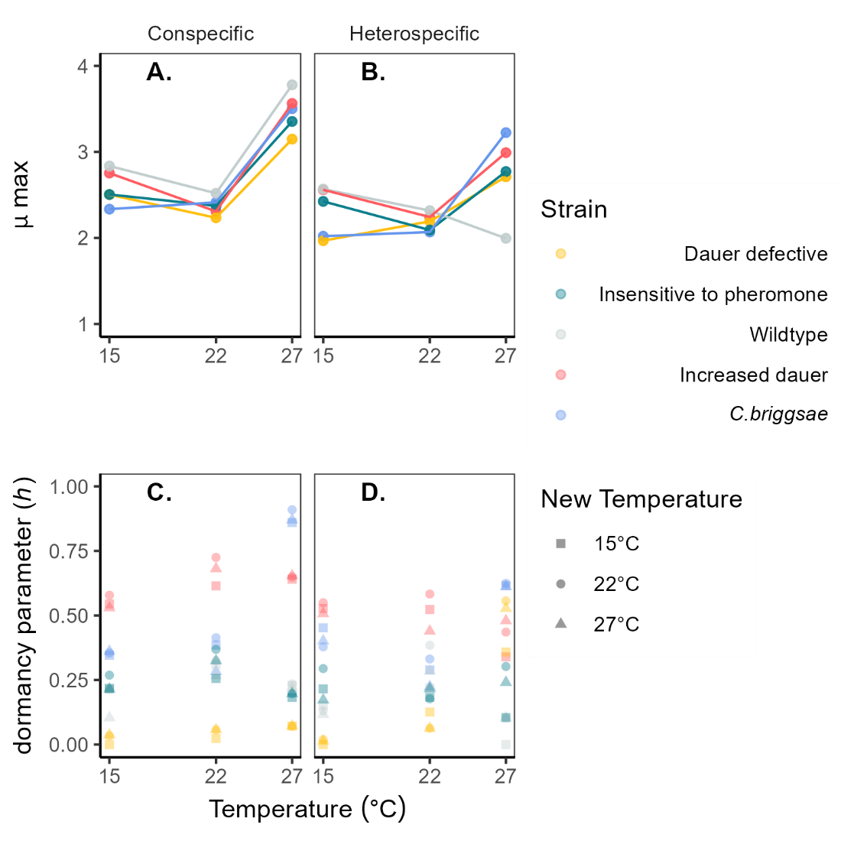

**Fig. S3.** Maximum growth rate **(**µ max**)**(A,B) anddormancy parameter (*h*)(fraction of the population in dauer)(C,D) at each temperature for the conspecific (A, C) and heterospecific (B, D) treatments. In our simulations in the main text of the paper, we used the monoculture (conspecific) parameters. Most parameters were similar, however we weren’t confident in the heterospecific dauer defective (knockout) treatment dormancy estimates due to contamination/counting errors.

**Table S1.** The dormancy parameter (*h*) that we used in model simulations, calculated as the fraction of the population in dauer. The top temperature is the experimental temperature that the population grew under and the bottom value is the temperature that the dauer worms were reactivated in.We used a single *C. briggsae* strain, JU1080.

|  |  |  |  |  |  |  |  |  |  |  |  |  |  |
| --- | --- | --- | --- | --- | --- | --- | --- | --- | --- | --- | --- | --- | --- |
|  |  | **15°C** | | | | **22°C** | | | | **27°C** | | | |
| **Species** | **Dauer manipulation** | **15°C** | **22°C** | **27°C** | **15°C** | | **22°C** | **27°C** | **15°C** | | **22°C** | **27°C** |
| *C. briggsae*  *(*JU1018) | Wild type-myo-2-RFP | 0.345 | 0.355 | 0.361 | 0.385 | | 0.414 | 0.283 | 0.860 | | 0.910 | 0.870 |
| *C. elegans* |  |  |  |  |  | |  |  |  | |  |  |
| CGC59 | Wild type | 0.214 | 0.214 | 0.103 | 0.309 | | 0.325 | 0.267 | 0.228 | | 0.235 | 0.218 |
| DR476 | Dauer defective | 0.000 | 0.033 | 0.037 | 0.024 | | 0.057 | 0.057 | 0.071 | | 0.071 | 0.071 |
| JT646 | Insensitive to dauer pheromone | 0.218 | 0.269 | 0.215 | 0.256 | | 0.369 | 0.324 | 0.182 | | 0.197 | 0.197 |
| PY7505 | Increased dauer | 0.545 | 0.578 | 0.530 | 0.615 | | 0.725 | 0.681 | 0.640 | | 0.649 | 0.654 |

**Table S2.** The average number of days that we photographed plates for each strain, the estimated

maximum population size and 𝛍max parameter used in the model.

|  |  |  |  |  |  |  |  |
| --- | --- | --- | --- | --- | --- | --- | --- |
| **Species** | **Strain** | **Dauer manipulation** | **Temperature (°C)** | **Mean Days to starvation** | **Standard Deviation** | **Maximum population size** | **𝛍max** |
| *C. elegans* | CGC59 (WT) | Wild type | 15 | 12.9 | 0.991 | 143.00 | 2.84 |
| *C. elegans* | CGC59 (WT) | Wild type | 22 | 9 | 0 | 115.50 | 2.52 |
| *C. elegans* | CGC59 (WT) | Wild type | 27 | 6.57 | 0.787 | 175.67 | 3.78 |
| *C. elegans* | DR476 | Dauer defective (Knock Out) | 15 | 14.4 | 0.744 | 195.25 | 2.50 |
| *C. elegans* | DR476 | Dauer defective (Knock Out) | 22 | 9 | 0 | 124.00 | 2.23 |
| *C. elegans* | DR476 | Dauer defective (Knock Out) | 27 | 7.38 | 1.6 | 130.00 | 3.15 |
| *C. elegans* | JT646 | Insensitive to dauer pheromone | 15 | 13.8 | 1.16 | 223.00 | 2.51 |
| *C. elegans* | JT646 | Insensitive to dauer pheromone | 22 | 9 | 0 | 137.50 | 2.37 |
| *C. elegans* | JT646 | Insensitive to dauer pheromone | 27 | 7 | 0.926 | 89.67 | 3.35 |
| *C. briggsae* | JU1080 | WT-myo-2-RFP | 15 | 16.5 | 1.73 | 203.25 | 2.34 |
| *C. briggsae* | JU1080 | WT-myo-2-RFP | 22 | 9 | 0 | 123.25 | 2.41 |
| *C. briggsae* | JU1080 | WT-myo-2-RFP | 27 | 6.25 | 0.5 | 70.67 | 3.50 |
| *C. elegans* | PY7505 | Increased dauer | 15 | 13.4 | 1.19 | 85.25 | 2.75 |
| *C. elegans* | PY7505 | Increased dauer | 22 | 9 | 0 | 63.50 | 2.31 |
| *C. elegans* | PY7505 | Increased dauer | 27 | 7.5 | 1.51 | 85.33 | 3.56 |

**Table S3.** ANOVA results testing the interactions between temperature, the new temperature after replating dauer worms, and *C. elegans* strain on dauer worm production.

|  |  |  |  |  |  |
| --- | --- | --- | --- | --- | --- |
| *Factor* | *Df* | *SumSq* | *MeanSq* | *F value* | *Pr(>F)* |
| Temperature | 2 | 15797 | 7898 | 6.044 | **0.00322** |
| Strain | 4 | 71380 | 17845 | 13.655 | **4.37E-09** |
| New Temperature | 2 | 6727 | 3364 | 2.574 | 0.08078 |
| Temperature:Strain | 8 | 55856 | 6982 | 5.343 | **1.10E-05** |
| Temperature: New Temperature | 4 | 3686 | 921 | 0.705 | 0.59009 |
| Strain:New Temperature | 8 | 5499 | 687 | 0.526 | 0.83482 |
| Temperature:Strain:New Temperature | 16 | 18940 | 1184 | 0.906 | 0.56442 |
| Residuals | 111 | 145062 | 1307 |  |  |